Lecturer’s Name: Dr. Shane Wilson

Assessment Title: <insert title of CA>

Work to be submitted to: Blackboard learn

Date for submission of work: <insert date>

Place and time for submitting work: Online blackboard learn by 22:00

To be completed by the Student

Student’s Name: James Finn

Class: HDip Educators

Subject/Module: Coding with Syntax

Word Count (where applicable):

I confirm that the work submitted has been produced solely through my own efforts.

Student’s signature: 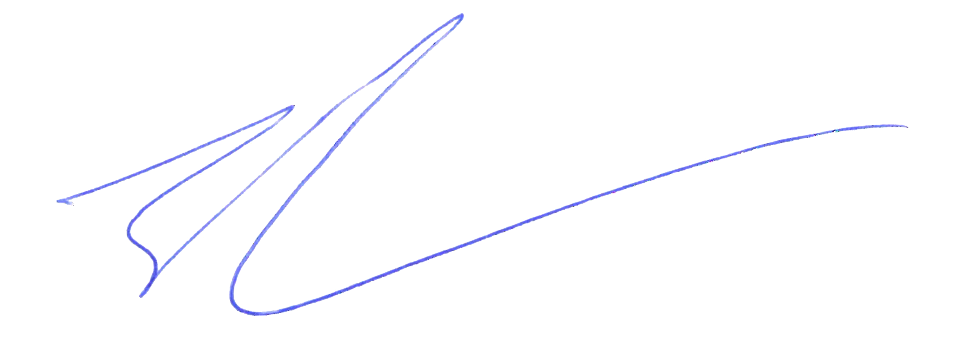 Date: 11/01/2024

|  |
| --- |
| **Notes**  **Penalties:** The total marks available for an assessment is reduced by 15% for work submitted up to one week late. The total marks available are reduced by 30% for work up to two weeks late. Assessment work received more than two weeks late will receive a mark of zero.  **Continuous Assessment:** For students repeating an examination, marks awarded for continuous assessment shall normally be carried forward from the original examination to the repeat examination.  **Declaration:**  I declare that this work is entirely my own and does not contain the words or ideas of someone else, whether published or not, without specific acknowledgement by relevant referencing. I have read and understood the ATU Donegal Plagiarism Policy on the “Student & Academic Policies” section of the ATU Donegal Website and understand plagiarism to include:   * Direct copying of text, images and other materials (electronic or otherwise) from a book, article, fellow student’s essay, handout, web page or other source without proper acknowledgement. * Claiming individual ideas derived from a book, article etc. as one’s own and incorporating them into one’s work without acknowledging the source of these ideas. * Overly depending on the work of one or more other sources without proper acknowledgement of the source, by constructing an essay, project etc., extracting large sections of text from another source and merely linking these together with a few of one’s own sentences.   I understand that it is my responsibility to familiarise myself with and to follow the Institute’s Assessment Regulations. I acknowledge that Incidents of alleged plagiarism and cheating are dealt with in accordance with the Institute’s Assessment Regulations and that penalties will be applied if I breach this policy.  Signed:_ A blue pen with a white background Date: 11/01/2024 |